Amila Shanaka

amila@ancientwisdom.biz

Abstract

This Document carry out testing for Picking app V 1.1 and implementation plan

aurora-Picking app test

Test plan and implementation plan

Contents

Test Case 1: user login with valid QR code 2

Test Case 2: user login with in valid QR code 4

Test Case 1: Delivery key will receive after click 5

1. Assign a delivery note to a staff member 8

Pending /completed sliding switch: 9

1. Status: Pending: 9

Pick Action 9

• Swipe Left: Pick One item 9

• Pick Multiple Items action: 9

• Swipe Right: mark Out of Stock / waiting 9

Cancel Pick Operation: 11

1. Action: Untick the icon 11

a. Msg Box Display verify to cancel operation 11

11

1. Select The icon to open Scanner 12

1. Scan the Bar Code 12

o Item Found: 12

Item List Shorting Method 14

1. Short Item list according to location. 14

2. Record all items weight 14

14

14

Short Item list according to location. 15

User Login

# Test Case 1: user login with valid QR code

1. Valid QR code generate by user following path
   1. Profile 🡺 API keys 🡺New API key 🡺 Picking App

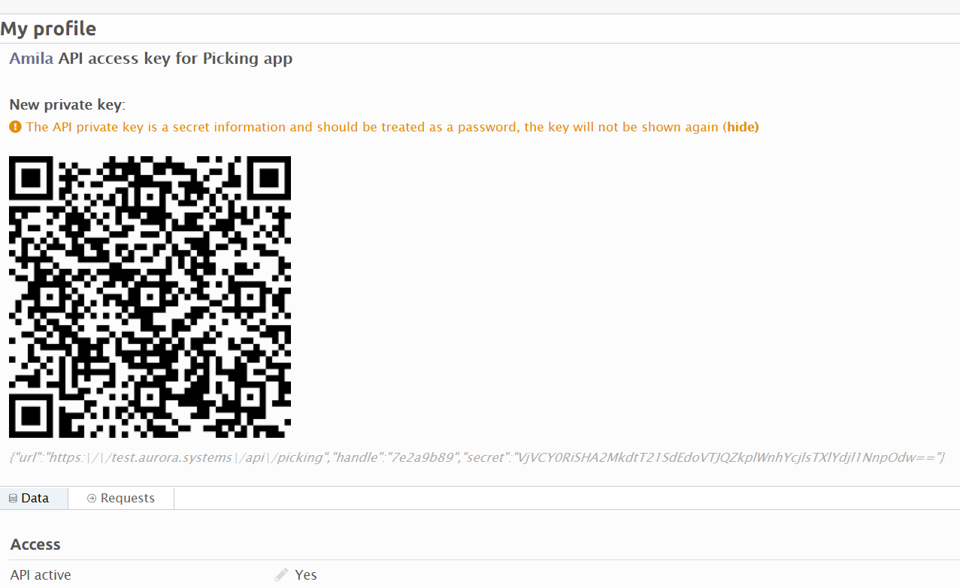

1. Scan QR code by App

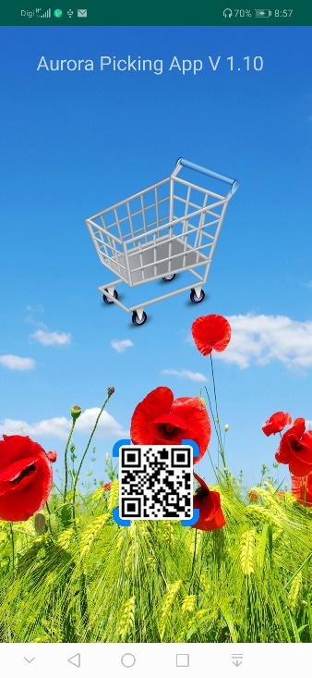

*tech info: Json

action=initialize

Parameters: *account_code, account_name, locale, worker_user_id, worker_alias,worker_type*

**Data in Db :** *"users_table";"ID";"account_code";"account_name";"locale";"worker_user_id";"worker_alias";"worker_type";"auth_key";*

1. Load to welcome activity

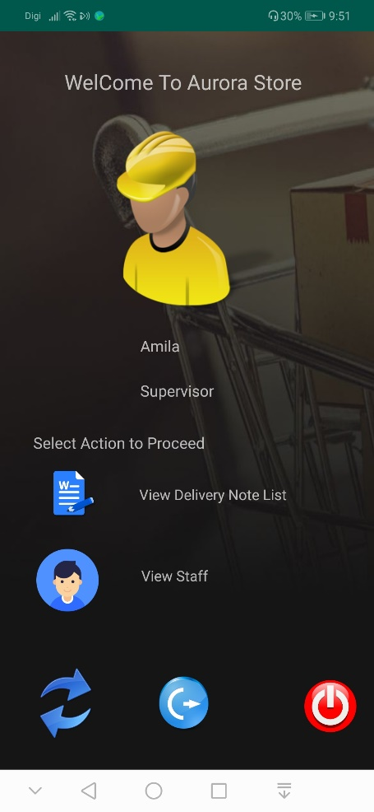

Information:

* Login User Name
* User role

# Test Case 2: user login with in valid QR code

1. Wrong API Key:

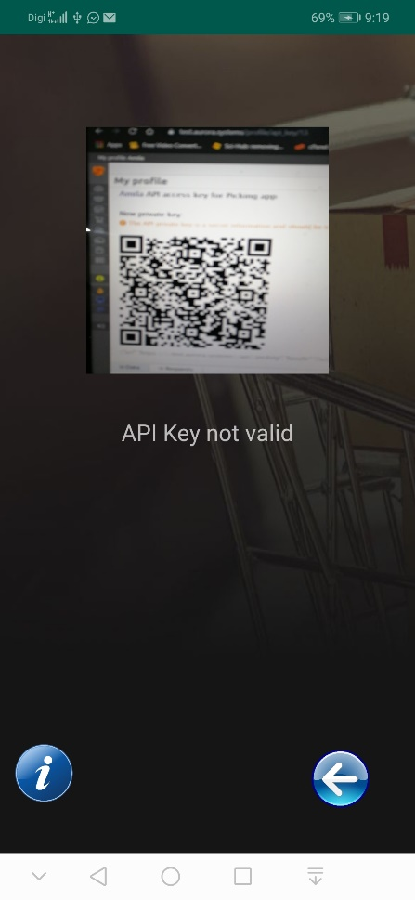

1. Any Server response will show in Text box in scan interface

Delivery Notes list view

# Test Case 1: Delivery key will receive after click

1. Delivery note list view

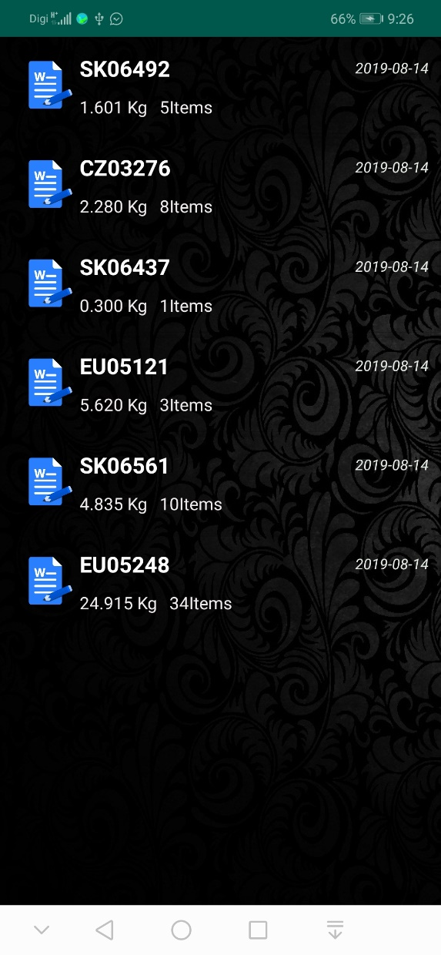

1. Drag Down: Refresh the list and display newly added job

*tech info: Json

action =get_deliveries_ready_to_be_picked

Parameters:  *Delivery Note Customer Key"Delivery Note Customer Key")("Delivery Note Date Created") ("Delivery Note Estimated Weight") ("Delivery Note ID") ("Delivery Note Key") ("Delivery Note Number Ordered Parts") ("Delivery Note Store Key") ("Delivery Note Type") ("Store Code"); ("Store Name");*

**Data in Db :** "itc_table";"DeliveryNoteCustomerKey""DeliveryNoteCustomerName""DeliveryNoteCustomerDate";"DeliveryNoteEstimatedWeight";"DeliveryNoteID";"DeliveryNoteKey";"DeliveryNoteNumberOrderedParts";"DeliveryNoteStoreKey";"DeliveryNoteType";"StoreCode";"StoreName";

1. Click on delivery note key – Load item List to be pick

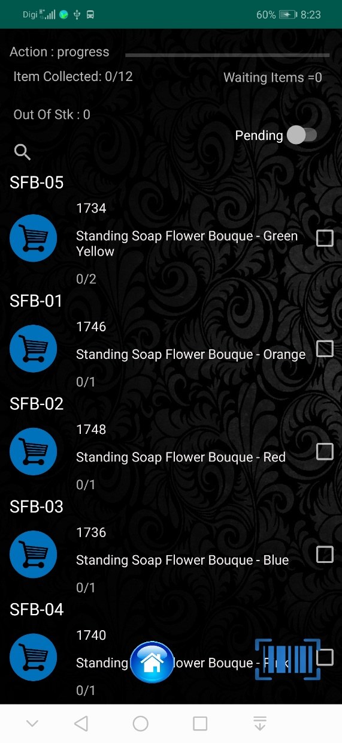

Dash Board information:

*tech info: Json

action =get_delivery_note_items

Parameters:  *("Inventory Transaction Key")("Part SKU") ("Part Package Description")("Part Package Weight") ("Required") ("Picked")("Out of Stock") ("Waiting") ("Location Key") ("Part Reference") ("Part SKO Barcode");*

**Data in Db : // each delivery note data will reloaded with current status**

"itm_table";"delivery_note_key";= "inventory_transaction_key";"part_sku";"pkg_des"; "part_package_weight";"to_pick";"picked";"out_of_stock";"waiting";"location_key";"part_reference";"part_sko_barcode"; "status";

* Progress Action
* Out of stock item
* Waiting items

1. 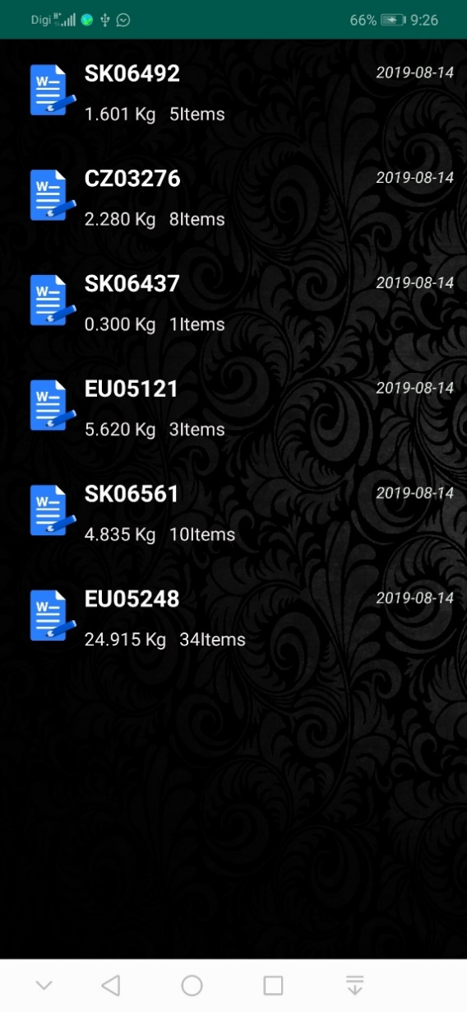Swipe Right – Load worker List
   1. Load worker list.
   2. *Load all staff type*

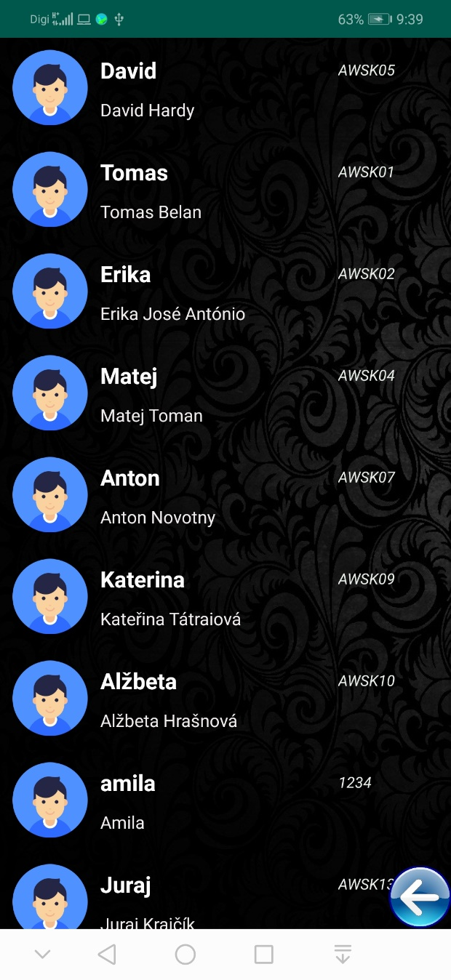

*tech info: Json

action =get_staff

Parameters:  *("Staff Key"); ("Staff Alias") ("Staff Name"); ("Staff ID"); ("Staff Main Image Key") ("Staff Roles");*

**Data in Db : // all staff list write in to table(**staff_table**)**

"StaffKey";"StaffAlias";"StaffName";"StaffID";"StaffMainImage";="StaffRoles";

Staff List Operations

# Assign a delivery note to a staff member

* Method: click on particular staff member
  + 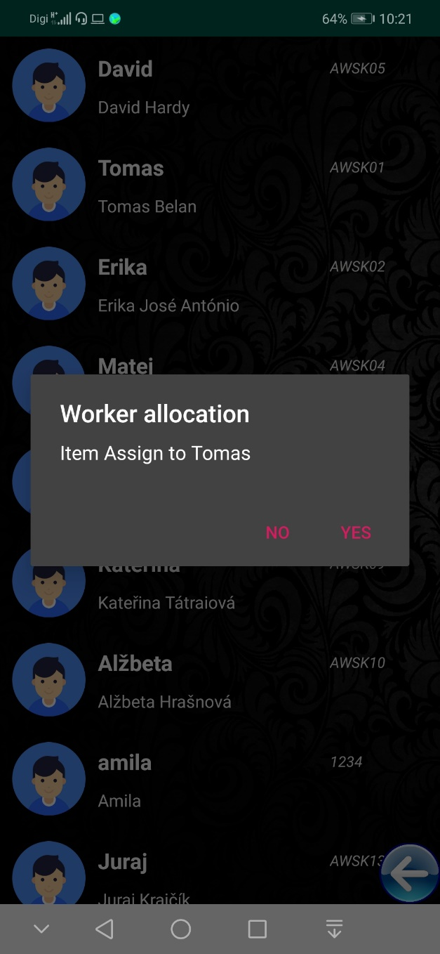Dialog box appear
* Yes= will assign worker to the delivery note, No = cancel operation, by doo the action again will it be allow to cancel previous worker assignment and assign new staff member to the delivery note.

*tech info: Json

action = set_picker

Parameters:  *("Staff Key"); ("delivery_note_key ")*

**Data in Db : No Db operation**

ITEM Operations

# Pending /completed sliding switch:

## Status: Pending:

* Show pending item List to be pick
* 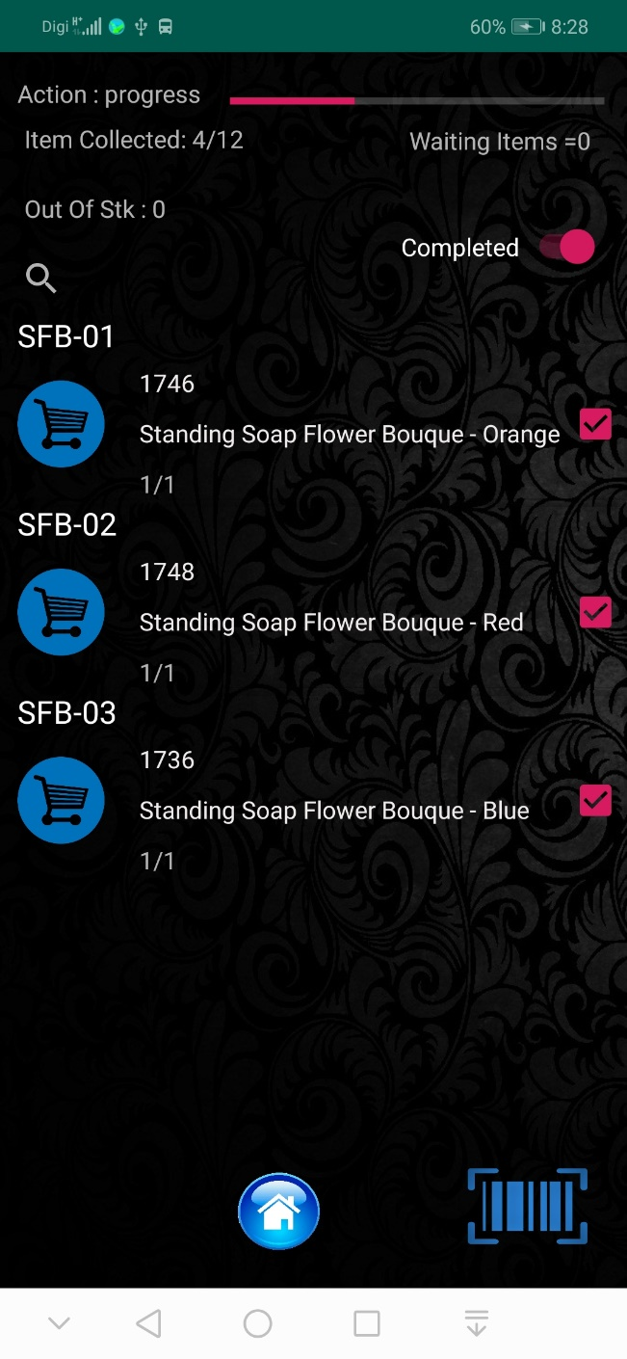Show picking status: eg 1/1 (picked/to pick)

# Pick Action

## Swipe Left: Pick One item



## Pick Multiple Items action:

* + Click on check box
  + 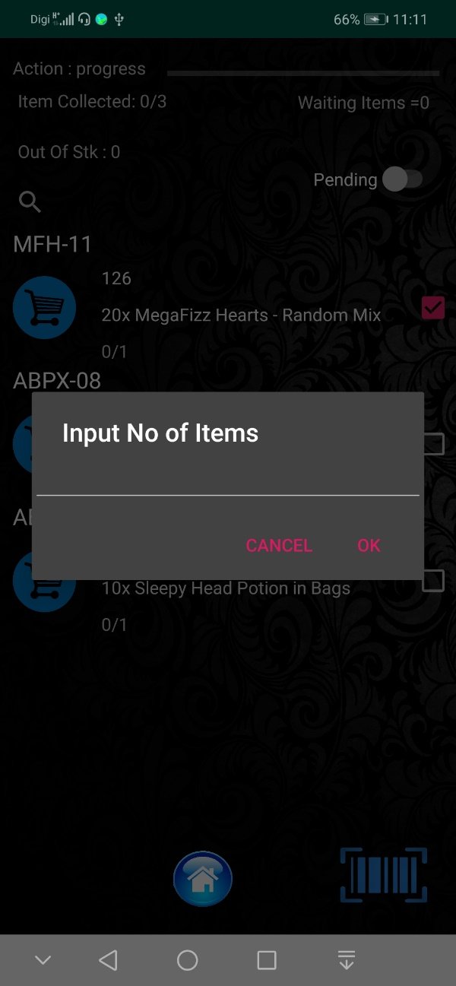Dialog box appear to in-put number of items
  + User input valid number of items 🡺 pic operation will proceed for number of items.
  + If user input not valid number Toast will display invalid quantity

## Swipe Right: mark Out of Stock / waiting



* 1. Menu will display

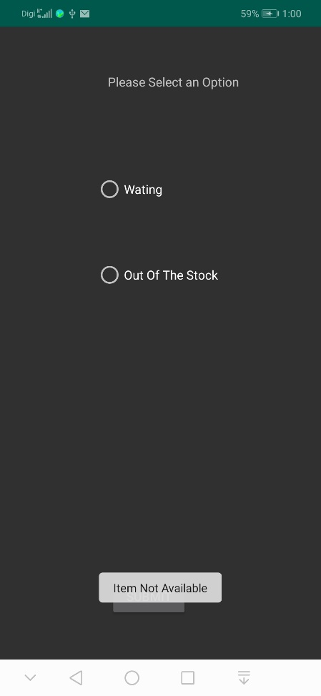

* 1. Select out of stock
     1. Item mark as out of stock

Server Result for Update Pick Action ={"state":"OK","data":{"state_index":20,"picked_quantity_components":"<span class=\"picked_quantity_done hide\"> \n <input class=\"picked_qty width_50\" style=\"background-color:rgba(192,216,144, 0.2)\" ondblclick=\"show_check_dialog(this)\" value=\"0\" readonly >\n <i class=\"fa fa-check fa-fw button add_picked \" aria-hidden=\"true\"\/><\/span><span data-settings='{\"field\": \"Picked\", \"transaction_key\":238573,\"item_key\":3482 ,\"on\":1 }' class=\"picked_quantity \" >\n <input class=\"picked_qty width_50\" value=\"\" ovalue=\"\"> <i onClick=\"save_item_qty_change(this)\" class=\"fa fa-plus fa-fw button add_picked \" aria-hidden=\"true\">\n <\/span>","location_components":"<i class=\"fa fa-fw fa-star success very_discreet button \" aria-hidden=\"true\" title=\"Stock in location: 15\"><\/i> <span class=\"discreet location\" location_key = \"790\" >F13B <\/span >","pending":1,"class_html":{"Delivery_Note_Picked_Label":"Picking","Delivery_Note_Picked_Percentage_or_Date":false}}}

Remark = “*Out of stock operation not function in the server inform to Mr Raul*”

*tech info: Json

action = set_as_not_picked_item

Parameters:  *("delivery_note_key" )("itf_key"); ("to_pick") ("quantity”)("out_of_stock")("waiting") ("status"); ("type"); ("Staff Key"); ("delivery_note_key ")*

**Data in Db : No Db operation**

public static final String *ITM_TABLE_NAME* = "itm_table";  
public static final String *ITM_COL_1* = "delivery_note_key";  
public static final String *ITM_COL_2* = "inventory_transaction_key";  
public static final String *ITM_COL_3* = "part_sku";  
public static final String *ITM_COL_4* = "pkg_des";  
public static final String *ITM_COL_5*= "part_package_weight";  
public static final String *ITM_COL_6*= "to_pick";  
public static final String *ITM_COL_7*= "picked";  
public static final String *ITM_COL_8*= "out_of_stock";  
public static final String *ITM_COL_9*= "waiting";  
public static final String *ITM_COL_10*= "location_key";  
public static final String *ITM_COL_11*= "part_reference";  
public static final String *ITM_COL_12*= "part_sko_barcode";  
public static final String *ITM_COL_13*= "status";



## Cancel Pick Operation:

### Action: Untick the icon

### Msg Box Display verify to cancel operation

1. Result: Un do pick operation for selected item

### 

*tech info: Json

action = cancel_picked_item

Parameters:  *("delivery_note_key" )("itf_key");*

**Data in Db : No Db operation**

Server Result Pick Action ={"state":"Error","msg":"Action cancel_picked_item not found"}

*please check the action in server

Bar code Scan to Pick Item

# Select The icon to open Scanner

## Scan the Bar Code

### Item Found:

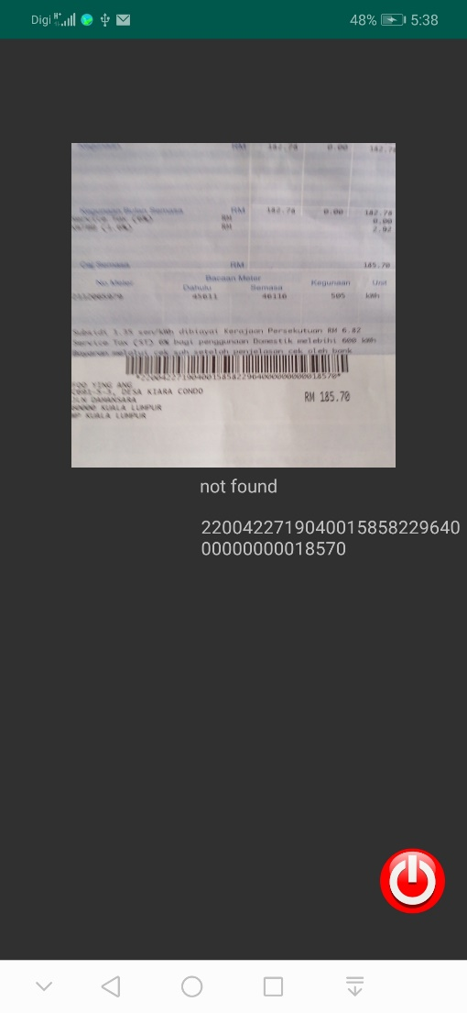Automatically execute pick action and return to the item list.

* Item Not found:

Message display item not found

BACK

ITEM Properties



*tech info: Json

action =get_delivery_note_items

Parameters:  *("Inventory Transaction Key")("Part SKU") ("Part Package Description")("Part Package Weight") ("Required") ("Picked")("Out of Stock") ("Waiting") ("Location Key") ("Part Reference") ("Part SKO Barcode");*

**Data in Db : // each delivery note data will reloaded with current status**

"itm_table";"delivery_note_key";= "inventory_transaction_key";"part_sku";"pkg_des"; "part_package_weight";"to_pick";"picked";"out_of_stock";"waiting";"location_key";"part_reference";"part_sko_barcode"; "status";

# Item List Shorting Method

## Short Item list according to location.

Requirement: need location database

* Need to get layout of a rack and warehouse
* Then setup location database
* Integrate with Location Barcode.

## Image result for sync serverRecord all items weight

****Purpose Method

## Image result for weigh scales

## Image result for barcode scanner app

1. Create app
   1. Scan Barcode
   2. Input weight in mobile screen
   3. Update server

## Short Item list according to location.

**IMPLEMENTATION PLAN**

1. Test the App in real environment
2. Report any Bug / issue.
3. Fix the issue
4. Introduce new feature as required
5. Implement new features
6. Check the app achieve the objectives
7. UI changes